***Project Title***

*Assessing Local Uncertainty in Non-Stationary*

*Scale-Variant Geospatial Data*

***Principal Investigator***

*Susan Colarullo, Hydrologist*

*New Jersey Water Science Center*

*U.S. Geological Survey*

*810 Bear Tavern Rd., Suite 206*

*W. Trenton, New Jersey 08628*

*(609) 771-3922*

[*colarull@usgs.gov*](mailto:colarull@usgs.gov)

***Primary Contact***

*Susan Colarullo*

***Project Description***

***Background***

Watershed managers rely on geospatial datasets depicting land use, hydrography, soil and geologic properties, vegetative cover, elevation, contaminant sources, and other distributed processes to make informed decisions about the allocation of scarce water resources between competing demands of human growth and aquatic ecosystem integrity. These spatial datasets, however, are imperfect. They differ from real-world distributions that they represent because of uncertainties inherent to data collection. Since watershed management decisions inherit the accuracy of geospatial data used to inform them, the reliability of watershed management decisions is only as good as the accuracy of these datasets.

Producers of GIS spatial datasets in the United States are required by Federal Geographic Data Committee (FGDC) metadata standards to report estimates of error (SDTS Task Force, 1996). Elements of the Data Quality section of the FGDC Content Standard for Digital Metadata (CSDGM) include positional and attribute error. Both sources of error contribute to data uncertainty, often in ways that are difficult to distinguish from one another. Error is typically reported using summary statistics derived by comparing ground measurements with dataset values for a subset of the data. This approach treats uncertainty as if it were the same at every location, or as a global phenomenon. In reality, uncertainty in spatially-distributed data is local in nature, varying from one location to another depending on the unique characteristics of the data and on the methods used to measure it or simulate it using deterministic rainfall-runoff models (Heuvelink and others, 1989; Openshaw, 1989; Fisher, 1991; Lee and others, 1992; Englund, 1993; Goodchild, 1995; Unwin, 1995; Burrough and other, 1996; Ehlschlaeger and others, 1997).

Local variations in uncertainty of distributed data occur for a number of reasons. Uncertainty close to measurement locations will tend to be smaller, increasing with greater distance from them at a rate dictated by the correlation scale of the data. It will be larger in regions where the data is most spatially variable and smaller in areas where it is not. Further compounding the issue of local uncertainty is its tendency to also vary with spatial scale, with higher levels of uncertainty typically associated with measurements collected over larger scales of spatial resolution. This dependence of dataset uncertainty on both location and scale should be incorporated into any framework used to assess the uncertainty of data critical to making watershed management decisions.

If spatial variations in the distributed data demonstrate approximate periodicity over space, the data can be treated as a stationary gaussian random process with statistics that are constant over space, and global measures of uncertainty. shows an example of a stationary gaussian process in the time domain, but the concept is the same when analyzing gaussian processes in space. Traditional geostatistical methods for assessing data uncertainty are rooted in the assumption that the distributed process is gaussian.

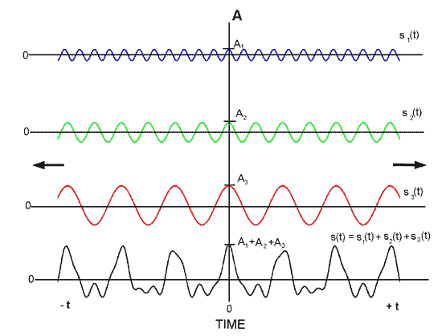

Figure 1. Stationary gaussian process in time, as the sum of cosine functions with differing frequencies

(from <http://130.191.21.201/multimedia/jiracek/dga/spectralanalysis/examples.html>).

Many of these geostatistical techniques rely on techniques of Fourier analysis to bring the dataset into the frequency domain, treating the stationary, scale-invariant dataset as the sum of an infinite number of shifted sine basis functions that extend throughout the spatial domain. Hydrologists and other physical scientists have made extensive use of such Fourier techniques to assess the global uncertainty of geospatial datasets (Bakr and others., 1978; Dettinger and Wilson, 1981; Gutjahr and Gelhar, 1981; Dagan, 1982; Mizell and others, 1982; Gelhar and Axness, 1983; Borgmanand and others, 1984; Naff and Vecchia, 1986; Dikow, 1988; McLaughlin and Wood, 1988; Vomvoris and Gelhar, 1990; Robin and others, 1993). These estimates of uncertainty represent average error, in some mean-squared sense, and are assumed to apply locally as well as globally. They are well-suited to analyzing distributed processes that were created as the result of large-scale spatially-invariant geophysical influences.

Most naturally occurring distributed datasets, however, are not gaussian (see ). Their mean, variance, and correlation scale change over space in response to the local geophysical processes that formed them. They may exhibit non-stationary behavior at a variety of scales, including hierarchies of continuously-evolving scales of spatial variation (Neuman, 1990). Such scale-dependent structure often occurs when a variety of geophysical processes, each characterized by its own natural scale of variation, collectively produce the observed geospatial dataset. In the presence of such non-stationary, scale-variant behavior, global estimates of error derived using standard gaussian geostatistical techniques will not accurately reflect local data uncertainty and local watershed management decisions based on them may be seriously compromised.



Figure 2. Non-stationary process in time

(from <http://www.iro.umontreal.ca/~lisa/seminaires/22-07-2005.pdf>)

As described previously, traditional Fourier methods of estimating non-local uncertainty are based on the assumption that the statistical behavior of the distributed process does not change over space or scale, and are appropriate only for application to stationary, scale-invariant geospatial datasets that exhibit strong global periodicities. Wavelets, on the other hand, are small waves characterized by locally-periodic structure that dampens out over space, as shown in . The compact support of wavelet basis functions over space is what makes them useful for analyzing local structure. Wavelet transforms range from short, high-frequency functions capable of resolving small-scale features to long, low-frequency functions able to preserve large-scale structure.

How do wavelets handle spatial variations at multiple scales? illustrates a set of wavelets obtained by re-scaling or ‘dilating’ the continuous Mexican Hat mother wavelet shown in by the power of two. Each wavelet describes data variability at a particular scale of spatial resolution, independent of variability at all other spatial scales. Some wavelets, such as the continuous Haar wavelet transform presented in , are particularly adept at characterizing spatial variability in the presence of sharp discontinuities frequently encountered in natural distributed processes influenced by large scale formative processes. In practice, discrete wavelet transforms are used to avoid the large computational burdens associated with oversampling in highly-redundant low frequency ranges.

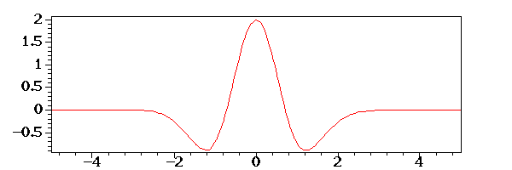

Figure 3. Mexican Hat wavelet

(from <http://www.rose-hulman.edu/~brought/Epubs/mhc/modelwaveforms.html>)

 



Figure 4. Wavelets obtained by scaling and translating the Mexican Hat mother wavelet

(from <http://www.iro.umontreal.ca/~lisa/seminaires/22-07-2005.pdf>).

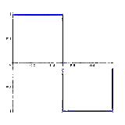

Figure 5. The Haar wavelet (from  [http://www.math.yale.edu/~mmm82/haar.html](http://www.rose-hulman.edu/~brought/Epubs/mhc/modelwaveforms.html))

shifted sine waves of various frequencies, wavelet analysis involves decomposing the process into shifted and scaled versions of the mother wavelet. Decomposition is performed by translating each scaled wavelet over the space domain and obtaining the coefficients of the wavelet transform at each location. These coefficients, which are distributed over both space and scale and are uncorrelated to one another, provide comprehensive information about the amount of variability residing in the dataset at each location and scale, can be used to assess local data uncertainty. Since each wavelet characterizes the data at a different scale of resolution, dataset variation at many frequencies can be simultaneously accounted for at each location.

***Hypothesis***

The local support of wavelets and their ability to handle more than one scale of variation make them well-suited to analyzing local, scale-dependent behaviors of natural distributed processes (Katul and others, 1994, 1997, 2001). Many of the natural processes used to make water resource decisions exhibit non-stationary, scale-variant structure because the very processes that formed them varied over both space and scale. Geologic processes responsible for soil and aquifer formation, for example, range from small-scale fluvial sediment transport mechanisms to large-scale tectonic influences. Wavelets provide a useful framework for explicitly quantifying uncertainty in natural processes and for assessing the fitness of datasets for making sound water-resource decisions.

illustrates how wavelet analysis using provides information about the local, scale-variant structure inherent to the kind of natural dataset typically encountered when making water resource decisions. Wavelets of varying scale, with s=1 for the mother wavelet and larger values of s for increasingly dilated wavelets, are translated beginning at the start of the process at regular intervals. The wavelet function is multiplied by the signal, integrated over all space, and multiplied by 1/sqrt(s) to normalize the resulting amplitude. The wavelet at scale s=1is then shifted towards the right by tauamount to the location t=tau, and the above equation is computed to get the transform value at t=tau , s=1in the time-frequency plane. This procedure is repeated until the wavelet reaches the end of the signal. One row of points on the time-scale plane for the scale s=1 is now completed. The above procedure is repeated for every value of s. Every computation for a given value of s fills the corresponding single row of the space-scale plane. When the process is completed for all desired values of s, the wavelet transform of the signal has been calculated. By performing this process of translating each wavelet and transforming the data spanning each wavelet support, the variance of the process at each location and scale can be plotted as uncorrelated coefficients in a space-scale plot, as shown in . All space- and scale-dependent behavior of the process is contained in the wavelet transform, and can be used to reconstruct the process or to generate many equally-probable alternate realizations by randomly selecting subsets of wavelet coefficients

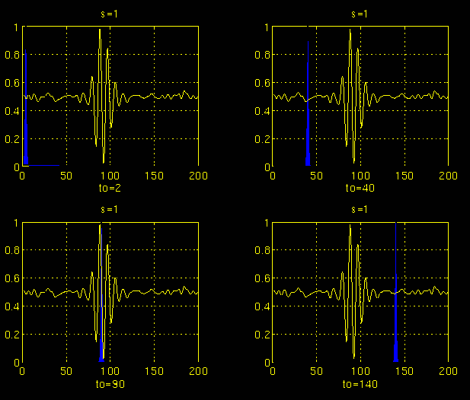

Figure 6. Translating a Morlet wavelet of scale s=1 through the process

(from http://users.rowan.edu/~polikar/WAVELETS/WTpart3.html).

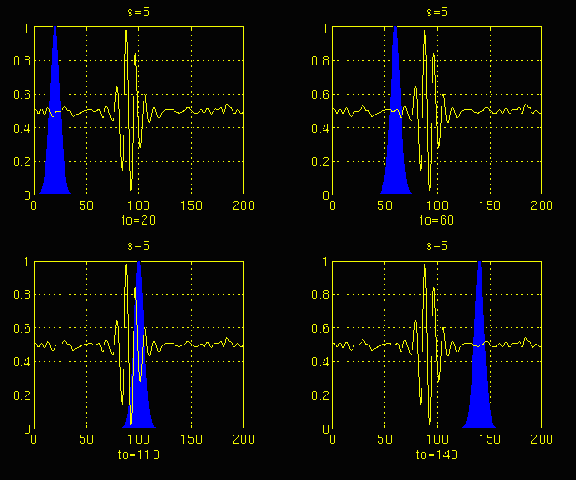

Figure 7. Translating a Morlet wavelet of scale s=5 through the process

(from http://users.rowan.edu/~polikar/WAVELETS/WTpart3.html).

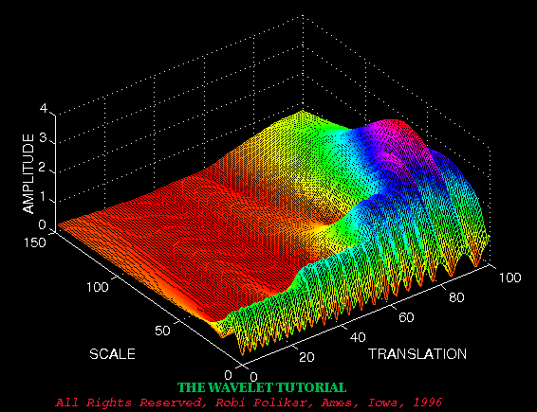

Figure 8. Plot of wavelet amplitudes over scale and translation

(from http://users.rowan.edu/~polikar/WAVELETS/WTpart3.html).

***Objectives and Approach***

The objectives of the proposed research are to:

* Develop a methodology for assessing local uncertainty in non-stationary, scale-variant natural processes; and
* Build a user-friendly GIS tool within the ArcGIS framework to implement the local uncertainty analysis.

As discussed previously, wavelets provide a useful tool for assessing local spatial variations in non-stationary, scale-variant natural processes. They differ from standard geostatistical techniques that assume the distributed process is statistically stationary and governed by a single characteristic scale of spatial variation. How do we translate understanding of non-stationary, scale-variant spatial structure obtained from wavelet analysis into estimates of local uncertainty?

Any distributed dataset represents a single possible set of geospatial data from among all possible datasets. To see that this is true, imagine the addition of a piece of data to the dataset. The resulting dataset will differ from the one that contained all the original data. Likewise, removal of a piece of data will produce a different dataset. This dependency of the dataset on the particular pieces of data collected occurs whenever we lack complete knowledge about the distributed process. It remains the principal source of uncertainty in most geospatial datasets.

We can mimic this lack of knowledge by randomly re-sampling the observed dataset, artificially producing an alterative dataset that is close to the original dataset but containing local error. If we do this repeatedly and in the same manner each time using a Monte Carlo approach, an ensemble of equally-probable datasets, or realizations, can be generated. illustrates how N alternative datasets might be generated by repeatedly re-sampling 23 of the 30 original data points, replacing the 7 omitted data points before each episode of re-sampling. In effect, this process of re-sampling with replacement, called bootstrapping, locally perturbs the dataset (Davison and Hinkley, 1997; Efron and Tibshirani, 1993). Collectively, the ensemble of N perturbed datasets provides us with information needed to assess local dataset uncertainty, by allowing us to estimate the variance at each location, as shown in .

Since bootstrapping does not involve making any assumptions about the global probabilistic behavior of dataset error, it would appear to be well-suited to the problem of assessing local uncertainties caused by non-stationary scale-variant influences. However, the random sampling inherent to bootstrapping requires that each piece of data be independent of all other data in the dataset. When the data are correlated over space, as they typically are for natural processes, bootstrapping can produce biased estimates of statistical properties at a point. To overcome this problem, we re-sample in the wavelet domain where the data are uncorrelated, rather than in the space domain (Percival and others, 2001; Breakspear and others, 2003). When the wavelet coefficients are brought back into the space domain, they provide an alternative dataset that preserves overall spatial structure contained in the original dataset, minus local structure associated with wavelet coefficients not re-sampled by the bootstrapping algorithm.



**2**

**. . . N**

**1**

Alternate, Equally-Probable Datasets

 

Figure 9. Bootstrappping generates N equally-probable alternative datasets.

To implement the non-stationary, scale-variant uncertainty analysis, an ArcMap UIButton tool will be developed within the ArcGIS framework. The tool will be attached to Visual Basic for Applications (VBA) code and triggered by the click event of the button control. Initially, the VBA code will determine whether the user-specified data is a feature class that must be converted into the raster format required to perform the uncertainty analysis. After raster conversion, the tool will then perform a single wavelet analysis to obtain wavelet coefficients uniquely defining the spatial characteristics of the dataset. Localization of wavelets in space and frequency tends to produce sparseness in the distribution of non-zero wavelet coefficients over location and scale, a phenomenon that is well documented in the literature (Mallat, 1998). To account for such sparseness, the bootstrapping algorithm will automatically reject zero-valued coefficients during re-sampling. Depending on user-input specifications, the VBA code will then repeatedly apply the bootstrapping algorithm in the wavelet domain to produce an alternate realization, followed by an inverse wavelet transform to bring each realization back into the space domain. Finally, when the user moves the screen cursor over a particular location in the map view, the variance at that point will be displayed via the interface of the identify object class.



Figure 10. Estimating local variance from the ensemble of alternative equally-probable datasets.

***Expected Results/Products***

The PI is an experienced ArcObjects programmer, and has written ArcObjects code within both VBA and VB.NET programming environments. A sample of code recently written by the PI to test for a vector dataset layer and convert it to raster format is included in the appendix. The code references methods and properties on interfaces of the map document, map, layer, raster layer, raster, raster workspace, raster dataset, feature class, feature class descriptor, raster conversion operation, and raster analysis environment object classes.

Testing for and conversion of a feature class to raster format is the first step in bringing the spatial dataset into the wavelet domain, where it will be repeatedly re-sampled via bootstrappping, taken back into the space domain, and incorporated into the uncertainty analysis. Code to perform forward and inverse wavelet transforms is widely available on internet software developer user forums, including public domain fortran code distributed by Press and others (1992) for implementing Daubechies discrete wavelet transforms. This fortran code can easily be converted to VBA or Visual Basic .NET and included in the code executed by the uncertainty tool. Additional code to perform bootstrapping and other operations essential to the analysis will be added during the course of the project. The final ArcGIS uncertainty tool will be distributed in the form of an ArcMap template (.mxt) document or as a stand-alone VB.NET application distributed as a dll binary executable, along with a user’s manual that describes output and provides guidance on how the user should interpret results of the uncertainty analysis.

After the tool has been developed and fully documented, it will be applied to the two Highlands projects discussed in the Project Support section of this proposal. Specifically, the tool will be used to flag locations and scales at which uncertainty in datasets used to inform water resource plans in the Highlands is most dominant. It is at these locations and scales where collection of additional data would be most critical to reducing uncertainties in planning processes at state, county, watershed, and township scales.

Based on results of the proposed work, a journal article will be submitted to a peer-reviewed journal specializing in GIS content, such as the *International Journal of Geographical Information Systems,* The paper will describe details of the wavelet bootstrapping algorithm and its application to various Highlands datasets as a means of targeting locations and scales where future data collection efforts should be focused.

***Significance to the USGS Mission***

In support of the USGS mission to enhance our understanding of the Earth, mitigate losses from natural disasters, manage the allocation of scarce natural resources, and enhance environmental quality, the proposed study will provide user-friendly tools to assess local uncertainty in non-stationary, scale-variant geospatial datasets typically used to make critical water resource decisions. More specifically, the proposed research is expected to offer decision makers a better understanding of the accuracy of distributed data used to make water resource decisions, including those made to minimize flood- and drought-related loss of life and property, manage surface-water resources for human and ecological uses, protect and enhance water resources needed to sustain human health, aquatic health, and environmental quality, and promote well-informed development of the Nation’s resources for the benefit of present and future generations. A high degree of dataset uncertainty at a particular location and scale will indicate the need to collect additional data at or near that location at a scale of measurement close to the scale where uncertainty is high, allowing greater reliability in plans developed at that site and scale. Conversely, smaller uncertainty in data observed at a given point and scale of resolution will suggest a much lower priority be placed on data collection at or near the point at the measurement scale used to collect the data, and that resource allocation plans based on the data can be made with much greater confidence.

The proposed research will also contribute to the CEGIS mission by providing a tool that can help water resource managers more fully understand linkages between anthropogenic factors and environmental quality, particularly in the context of how distributed but poorly measured landscape disturbances may affect the integrity of biotic ecosystems, enhancing GIS expertise currently lacking in water resource and other USGS disciplines.

***References***

Bakr, A., L. Gelhar, A. Gutjahr, and J. MacMillan (1978), Stochastic analysis of spatial variability in subsurface flows: 1. A comparison of one and three-dimensional flows, *Water Resour. Res*., 14, 263– 271.

Borgman, L., Taheri, M. and R. Hagan (1984), Three-dimensional frequency domain simulations of geological variables, in *Geostatistics for Natural Resources Characterization, Part I,*  G. Verly and others (eds.),Kluwer Academic, 517-541.

Breakspear, M., Brammer, M., and P.A. Robinson (2003), Construction of multivariate surrogate sets from nonlinear data using the wavelet transform, *Physica*, D 182, 1, 1-22.

Burrough, P.A., van Rijn, R, M. Rikken (1996), Spatial data quality and error analysis issues: GIS functions and environmental modeling. In Goodchild M. and others (eds.), *GIS and Environmental Modeling: Progress and Research Issues,* GIS World Books, Fort Collins, CO, 29-34.

Dettinger, M., and J. Wilson (1981), First-order analysis of uncertainty in numerical models of groundwater flow: 1. Mathematical development, *Water Resour. Res*., 17, 149–161.

Dagan, G. (1982), Stochastic modeling of groundwater by unconditional and conditional probabilities, 1, Conditional simulation and the direct problem. *Water Resour. Res.,* 18, 813-833.

Davison, A.C., and Hinkley, D.V. (1997), Bootstrap methods and their application, *Cambridge Series on Statistical and Probabilistic Mathematics*, 1. Cambridge: Cambridge University Press.

Dikow, E. (1988), Stochastic analysis of groundwater flow in a bounded domain by spectral methods, *Transp. Porous Media*, 3, 173–184.

Efron, B., and R.J. Tibshirani (1993), *An introduction to the bootstrap.* Monographs on Statistics and Applied Probability, 57, New York, NY: Chapman & Hall.

Ehlschlaeger, C.R., Shortridge, A.M., and M.F. Goodchild (1997), Visualizing spatial data uncertainty using animation, *Computers & Geosciences*. 23(4), 387-395.

Englund, E.J. (1993), Spatial simulation: environmental applications, in Goodchild, M.F., Parks, B.O., L.T. Steyaert (eds.), *Environmental modeling with GIS,* Oxford Press, New York, 432-437.

Fisher, P.F. (1991). First experiments in viewshed uncertainty: the accuracy of the viewshed area, *Photogrammetric Engineering & Remote Sensing*. 57(10), 1321-1327.

Gelhar, L., and C. Axness (1983), Three-dimensional stochastic analysis of macrodispersion in a stratified aquifer, *Water Resour. Res*., 19, 161–180.

Goodchild, M.F. (1995), Attribute accuracy, in Guptil, S.C. and J.L. Morrison.(eds.), *Elements of Spatial Data Quality*. Elsevier, London, 59-79.

Gutjahr, A. L., and L. W. Gelhar (1981), Stochastic models of subsurface flow: Infinite versus finite domains and stationarity, *Water Resour. Res*., 17, 337– 350.

Heuvelink, G.B., Burrough, P.A., and A. Stein (1989), Propagation of errors in spatial modeling with GIS,. *International Journal of Geographical Information Systems*. 3(4), 303-322.

Katul, G.G., Lai, C.T., Schafer, K., Vidakovic, B., Albertson, J.D., Ellsworth, D., and R. Oren (2001), Multiscale Analysis of Vegetation Surface Fluxes: from Seconds to Years, *Adv. Water Resour.* , 24, 1119-1132.

Katul, G.G., Hsieh, C.I., and J. Sigmon (1997), Energy-inertial scale interaction for temperature and velocity in the unstable surface layer, Boundary-Layer, *Meteorol*. 82, 49-80.

Katul, G.G., Parlange, M.B., and C.R. Chu (1994), Intermittency, local isotropy, and non-Gaussian statistics in atmospheric surface layer turbulence, *Physics of Fluids,* 6, 2480-2492.

Lee, J., Snyder, P.K., P.F. Fisher (1992), Modeling the effect of data errors on feature extraction from digital elevation models, *Photogrammetric Engineering & Remote Sensing,* 58(10), 1461-1467.

Mallat, S. (1998), *A Wavelet Tour of Signal Processing*, Academic Press, New York, 637 p.

McLaughlin, D., and E. F. Wood (1988), A distributed parameter approach for evaluating the accuracy of groundwater model predictions: 1. Theory, *Water Resour. Res*., 24, 1037– 1047.

Mizell, S., A. Gutjahr, and L. Gelhar (1982), Stochastic analysis of spatial variability in two-dimensional steady groundwater flow assuming stationary and nonstationary heads, *Water Resour. Res*., 18, 1053– 1067.

Naff, R., and A. Vecchia (1986), Stochastic analysis of three-dimensional flow in a bounded domain, *Water Resour. Res*., 22, 695– 704.

Neuman, S.P. (1990), Universal scaling of hydraulic conductivities and dispersivities in geologic media, *Water Resour. Res.,* 26(8), 1749-1758.

Olden, J.D. and N.L. Poff (2003), Redundancy and the choice of hydrologic indices for characterizing streamflow regimes: *River Research And Applications*, 19, 101-121.

Openshaw, S. (1989), Learning to live with errors in spatial databases, in Goodchild, M.F. and S. Gopal (eds.), *Accuracy in Spatial Database,*. Taylor & Francis, London, 263-276.

Percival, D.B., Sardy, S., and A.C. Davison (2001). Wavestrapping Time Series: Adaptive Wavelet-Based Bootstrapping, in *Nonlinear and Nonstationary Signal Processing,* W.J. Fitzgerald, R. L. Smith, A. T. Walden and P. C. Young (eds.), Cambridge University Press.

Poff, N. L, Allan, J. D. Bain, M. B. Karr, J. R. Prestegaard, K.L. Richter, B.D. Sparks, R.E. and J.C. Stromberg (1997), The natural flow regime: A paradigm for river conservation and restoration, *BioScience*, 47, 769-784.

Poff, N.L. and J.V. Ward (1989), Implication of streamflow variability and predictability for lotic community structure: A regional analysis of streamflow patterns, *Canadian Journal of Fisheries and Aquatic Sciences*, 46, 1805-1818.

Press, W. H., Flannery, B. P., Teukolsky, S. A., W.T. Vetterling (1992), *Numerical Recipes in FORTRAN*, Second Edition, Cambridge University Press, 584-599.

Robin, M. J., Gutjahr, A. L., Sudicky, E. A. and J.L. Wilson (1993), Cross-correlated random field generation with the direct Fourier transform method, *Water Resour. Res.,* 29, 2385-2397.

SDTS Task Force. (1996). The spatial data transfer standard: guide for technical managers, U.S. Dept. of the Interior. <ftp://sdts.er.usgs.gov/pub/sdts/articles/pdf/mgrs.pdf>

Unwin, D.J. (1995), Geographical information systems and the problem of ‘error and uncertainty’, *Progress in Human Geography,* 19(4), 549-558.

Vomvoris, E. G. and L.W. Gelhar (1990), Stochastic analysis of the concentration variability in a three-dimensional heterogeneous aquifer, *Water Resour. Res*., 26, 2591-2602.

Zhang, D. (1998), Numerical solutions to statistical moment equations of groundwater flow in nonstationary, bounded heterogeneous media, *Water Resour. Res*., 34, 529– 538.

***Project Support***

This research will support several ongoing USGS studies being conducted in the New Jersey Highlands, a 1,250 square mile area that provides water for a population of more than 5 million people in New Jersey (http://www.highlands.state.nj.us/njhighlands/actmaps). Undisturbed forests in the Highlands have historically protected both surface-water and groundwater water supply and quality, by acting as a natural buffer to extreme flow events and environmental degradation. However, these forested lands are rapidly being lost to subdivisions and urban development. The U.S. Forest Service estimated that roughly 5,000 acres of forest and farmland was lost annually between 1994 and 2004 to urban and suburban development in the Highlands, threatening New Jersey’s water supply and the health of its aquatic ecosystems (http://www.state.nj.us/dep/newsrel/2004/crowntowers200405.htm). In response to this growing challenge, the USGS is cooperating with the New Jersey Highlands Council and the New Jersey Department of Environmental Protection (NJDEP) to assess the consequences of lost habitat and natural buffering capacity on water resource availability and quality in the Highlands.

Under the scope of one of these cooperative efforts, the New Jersey Water Science Center (NJWSC) of the USGS provides critical geospatial data to Highlands Council decision makers responsible for defining optimal rates of growth based on water availability, sustainability, and susceptibility. In accordance with the goals of the New Jersey Highlands Water Protection and Planning Act of 2004, the Highlands Council is developing a Regional Master Plan (RMP) based on scientifically robust principles. The RMP will ensure continued economic opportunity while protecting water supply and sustaining aquatic ecosystem viability. In the absence of meaningful estimates of geospatial data uncertainty, Council members must assume that their plans to limit or accommodate development are equally reliable across the full extent of the Highlands, without regard for the impact of local data uncertainties on statewide, county, township, and watershed zoning plans. The proposed CEGIS study will provide a tool to Highlands Council decision makers that they can use to better inform critical growth decisions made at all locations and scales relevant to the planning process. It will also provide quantitative information regarding locations where additional data collection would most improve the reliability of the RMP.

The USGS New Jersey Water Science Center is also working in collaboration with NJDEP to develop innovative methods for establishing passing streamflow requirements. Such requirements will help preserve natural streamflow variability critical to maintaining the integrity of aquatic ecosystems in the state. The NJDEP study relies on USGS continuous streamflow data to calculate ecologically relevant hydrologic indices describing natural flow variability (Poff and Ward, 1989; Olden and Poff, 2003). Predicted alterations in these hydrologic indices caused by projected changes in water demand, land use, and other anthropogenic processes represent measures of growth-related streamflow disturbance that will be used as surrogates for state-mandated TMDLs. To estimate these hydro-TMDLs in ungaged basins where streamflow records are not available, indices estimated in gaged basins will be regressed on various spatial datasets, including datasets characterizing stream channel and basin morphology, land use, soil and geologic properties, vegetative cover, recharge, and precipitation. Streamflow indices and hydro-TMDLs estimated for ungaged basins using these regression datasets will tend to inherit local dataset uncertainties. The proposed CEGIS study will help quantify the reliability of hydrologic disturbance indices inferred for ungaged basins, and also provide information about where additional collection of data would most improve the reliability of hydro-TMDLs.

***Budget - Year 1***

|  |  |  |  |
| --- | --- | --- | --- |
| **Budget Request** | | | |
| Fiscal Year 2007 Budget | Budget Amounts by Participating Cost Center Code |  | Total Year 1 |
|  | 2454 |  |  |
| Personnel Salary | 93,160 |  | 93,160 |
| Other Expenses: travel, equipment, and supplies | 0 |  | 0 |
| **TOTAL DIRECT** | **93,160** |  | **93,160** |

|  |  |  |  |
| --- | --- | --- | --- |
| Gross Assessment Rate for Each Participating Cost Center | 25.58% |  |  |
| **INDIRECT COSTS ESTIMATE** (Gross Assessment Rate Times Total Direct) | **23,830** |  | **23,830** |
| **TOTAL** | **116,990** |  | **116,990** |

***Appendix: Sample ArcObjects Code***

Private Sub RasterizeDataset_Click()

Dim pDoc As IMxDocument

Set pDoc = ThisDocument

Dim pMap As IMap

Set pMap = pDoc.FocusMap

Dim pLayer As ILayer

Set pLayer = pMap.Layer(0)

'Allow user to input name of workspace, then open it.

Dim DirName As String

DirName = InputBox("Input the name of the directory that you'd like

to use as the workspace:", "Input Name of WorkSpace")

Dim pWSF As IWorkspaceFactory

Dim pWS As IRasterWorkspace

Set pWSF = New RasterWorkspaceFactory

Set pWS = pWSF.OpenFromFile(DirName, 0)

'If feature layer, ask user to specify name of raster output,

cellsize, and attribute name, then convert to raster layer

If TypeOf pLayer Is IGeoFeatureLayer Then

'User inputs the name of the output grid, cellsize, and attribute

name.

Dim GridName As String

GridName = InputBox("Your dataset is in vector format, and must be

converted to a grid. Input the name of the grid where you'd like

to store the rasterized coverage:", "Input Name of Output Grid

for Vector Dataset")

Dim CellSize As Integer

CellSize = InputBox("Input the integer cell size. Note that the

smaller the cell size, the more accurate local uncertainty

estimates will be:", "Input Cell Size")

Dim AttributeName As String

AttributeName = InputBox("Input the name of the attribute that you'd

like to use to rasterize your dataset:", "Input Attribute Name")

'Get the featureclass for the featureclassdescriptor.

Dim pFeatLayer As IFeatureLayer

Set pFeatLayer = pLayer

Dim pFeatureClass As IFeatureClass

Set pFeatureClass = pFeatLayer.FeatureClass

'Create a FeatureClassDescriptor

Dim pFCDesc As IFeatureClassDescriptor

Set pFCDesc = New FeatureClassDescriptor

pFCDesc.Create pFeatureClass, Nothing, AttributeName

'Test for old raster file left from previous runs, and delete if it

exists.

On Error Resume Next

Dim pRasterDS As IRasterDataset

Set pRasterDS = pWS.OpenRasterDataset(GridName)

If Not pRasterDS Is Nothing Then

Set pDataset = pRasterDS

If pDataset.CanDelete Then pDataset.Delete

End If

'Set up the conversion environment.

Dim convert As IConversionOp

Set convert = New RasterConversionOp

Dim pEnv As IRasterAnalysisEnvironment

Set pEnv = convert

pEnv.SetCellSize esriRasterEnvValue, CellSize

'Convert to raster dataset.

Set pRasterDS = convert.ToRasterDataset(pFeatureClass, "GRID", pWS,

GridName)

'Convert the output raster dataset to layer and add to map.

Dim pRasterLayer As IRasterLayer

Set pRasterLayer = New RasterLayer

Dim pRaster As IRaster

Set pRaster = pRasterDS.CreateDefaultRaster

pRasterLayer.CreateFromRaster pRaster

pMap.DeleteLayer pLayer

Set pLayer = pRasterLayer

pMap.AddLayer pLayer

End If

End Sub